**1st Grade Halloween Party Plan**

| **Time** | **Activity** | **Participants** |
| --- | --- | --- |
| **9:15-9:30** | Prep while kids are in computer lab   * Tape up door hang * Set up each station   + Game station     - web poster on the closet door or near calming corner (blue tape only)     - Ping pong toss near calming corner   + Art station     - Leaves and markers on the curved “teacher table” near the sink. May need to move a few more tables over.     - Drying racks along the countertop.   + Building station- arrange some desks together towards the front middle of the room * Snacks/food on the back counter |  |
| **9:30-10:15** | Stations  6 kids x2 adults per station  15 min per station |  |
| **10:15-10:30** | Snack and story on the rug   * Clean up stations * Move desks back to original configurations * Put down table cloths, bat confetti * Bingo card at each spot * Stack of activity pages at each table |  |
| **10:30-11:00** | Group activity   * Wrap the mummy- 5 min? Groups of 3. 2 rolls per group * Bingo * Snack Break * Extra time- I Spy, Word Search, Maze, extra leaves |  |
| **11:00-11:20** | Clean up after kids go to library |  |

**1st Grade Fall Party Plan**

| Station | Activity | Supplies |
| --- | --- | --- |
| 1. Games | Pin the spider on the web   * Like pin the tail on the donkey. * Each kid has a spider with their name on it. * Blindfold each kid and spin 3 times. * Everyone gets treats ?extra candy for the winners? | Spider web poster  Spiders  Treats and treat bucket |
| Ping Pong ball toss   * Toss ping pong balls into holes in cardboard poster * 5 tosses per kid | Ping pong balls  Game set up |
| 2. Art | Coffee filter leaf painting   * Kids pick as many leaves as they want. Write their name on the back in pencil. * Kids color on each leaf with crayola washable markers. The more color, the better. * Put the leaf in the metal tray, spray with a water bottle until wet. * Put leaves on the drying rack. * Everyone gets treats | 200 Leaf shapes  Trays  Crayola markers  Pencil  Paper towels  Drying racks  Treats and treat bucket |
| 3 STEM | Toothpick building   * Set a timer for 10 minutes. * Kids build a tower as high as they can using dots and toothpicks * When the timer goes off, place a pumpkin on top of each one to see if it will hold. * Everyone gets treats. * Will need to disassemble towers after each group | Toothpicks  Dots  Mini pumpkins  Baby wipes  Treats and treat bucket |

**3rd Grade Halloween Party**

**Station 1: Skeleton Bridges**

Volunteer:

Materials

* 60 Qtips per group
* 20 popsicle sticks per group
* 20 pipe cleaners per group
* Scissors
* Ruler
* 1 bag of pumpkin candies

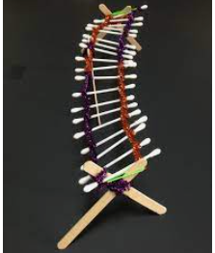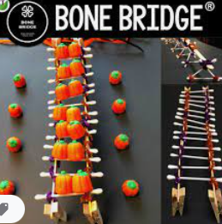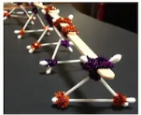

**Goal:** To make the longest AND strongest bridge. Measure length and then how many candy pumpkins that can sit on the bridge without breaking will determine the strongest.

**Station 2: Crafting Bookmarks, I Spy Handout (if we need to fill the time)**

Volunteer:

Materials

* Bookmark kits/paper/tool

**Station 3: Move the M&Ms, Room on the Broom**

Volunteer:

Materials:

* 30 straws
* 40 plates
* 2 bags of M&Ms
* 30 popsicle sticks
* 2 bags of candy pumpkins

**Goal:** To move as many M&Ms from one plate to another plate only using a straw (no hands) 😊 in 2 minutes. (If that feels like too much time you can totally adjust it!)

To put a popsicle stick in your mouth and balance 4 candy pumpkins (if that is too many you can totally decrease that # to what makes sense) for 1 minute.

**Station 4: Halloween Bingo, Candy in paper bags**

Volunteer:

Materials:

* Bingo set
* 8 paper bags
* 50 pieces of candy

**Station 5: Pin the Spider on the Web, Ping pong toss**

Volunteer:

Materials:

* Pin the Spider Game
* Ping pong toss Game
* Paper for scoring

**Group Activities**

* Wrap the mummy (6 rolls of toilet paper)
* I Spy Sheet (print 28 sheets)
* Halloween Word Search (print 28 sheets)

WHAT TO BUY

* Popsicle sticks (100)
* Halloween table covers (6)
* Halloween plates (60)
* Halloween napkins (40)